MED D - Specialized Member Services Team (SMST) - EGWP Opt Hold Release Process in FAZAL

General Information
Authorized to Attest
Releasing an Application on Opt Hold in FAZAL
Accessing Notes for an Application on Opt Hold in FAZAL
Resolution Time
Related Documents

Description: This document assists the Specialized Member Services Team (SMST) CCR when receiving from potential enrollees that have been receiving benefits through an Employer Group Waiver plan (EGWP).

General Information
Notes:
- Health Plans/EGWP - refer to the CIF to determine if the plan handles the situations outlined in this document.
  - If Client handles, follow direction provided in CIF.
  - If SMST handles, transfer to SMST. Refer to MED D - Guide to Transferring a Call.
- SilverScript (x9110) - Warm transfer to the SMST. Refer to MED D - Guide to Transferring a Call.
- For all other clients - refer to Transferring Calls to Dedicated Teams Process.
- Specialized Member Services Team (SMST) CCRs, follow the process outlined in this document.

MED D Customer Care Representatives (CCRs) may receive calls from potential enrollees that have been receiving benefits through an Employer Group Waiver plan (EGWP). These benefits typically would include medical, prescription, dental and vision coverage for active employees and/or retirees. Due to rising cost, many employers and union groups are making changes in the coverage they offer to retirees.

Once retirees become Medicare eligible, employers and union groups may make one of three decisions for their retirees:
Option | Then
Continue providing the retirees with full benefits. | - This is considered creditable coverage by CMS.  - The retiree would not need to choose a Medicare PDP, as they can only be enrolled into one creditable coverage plan at a time.
Drop all benefits for retirees. | - The retiree will be granted an SEP by CMS to choose their own Medicare coverage.
Allow the retirees the option to keep their medical, dental, and/or vision benefits, if they join a specifically selected Medicare standalone PDP. | - The retiree will be given a 21-day Opt-Out period to advise SilverScript to continue processing the enrollment into the Medicare PDP selected by the employer or union group or decline the enrollment.  - The retiree will receive notification of the 21-day Opt-Out period no later than 10 calendar days from the date their application was received.  - The Opt-Out period expires 21 days after the date on the Opt Out letter.

If the Opt Hold Release Date has passed or the plan has become effective, the beneficiary may not Opt Out of the EGWP.
- If the beneficiary does not want to participate in the plan, the beneficiary will have to disenroll from the plan.

Top of the Document

Authorized to Attest

Only the beneficiary, legal representative or SHIP Counselor can verbally attest. The SMST will use the below to determine if the caller is authorized to provide attestation:
If the caller is… | Then…
Legal representative | In order to process this attestation for (Beneficiary’s Name), I need to verify that you are authorized to act on their behalf under the laws of the State for which resides. If asked to provide evidence of that authority to Medicare, would you be able to do so?  Refer to MED D - Obtaining a Verbal Attestation from an Authorized Representative.
Non-authorized party (helping the beneficiary but is not the legal representative) | - Only the beneficiary or legal representative or SHIP Counselor is able to verbally attest.  - You can assist the beneficiary completing the attestation form and mailing to:  SilverScript  P.O. Box 30001  Pittsburgh, PA 15222-0330  OR fax to: SilverScript Bizfax at 866-552-6205  CCR Process Note: The CCR must put detailed notes in PeopleSafe Med D Inquiry tab that the non-authorized party is aware of the verbal attestation process.

Top of the Document

Releasing an Application on Opt Hold in FAZAL

To release an enrollment application on Opt Hold in FAZAL, the SMSTCCR will:
Step | Action
1 | Access the beneficiary’s account by searching the MED D tab in PeopleSafe by Last Name, First Name, Date of Birth or ask the beneficiary to provide the member ID (External ID) from the letter they received.  Do not use the Participant Inquiry search.  Note: If the beneficiary cannot be located in the MED D tab search, proceed to the next step.  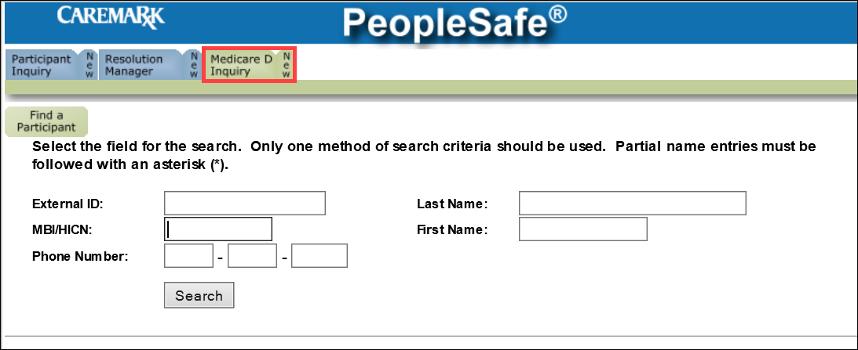  Refer to the MED D Enrollment - FAZAL work instruction.
2 | Log into FAZAL and search for the beneficiary’s application be using the Opt Hold – Opt Hold Queue search.  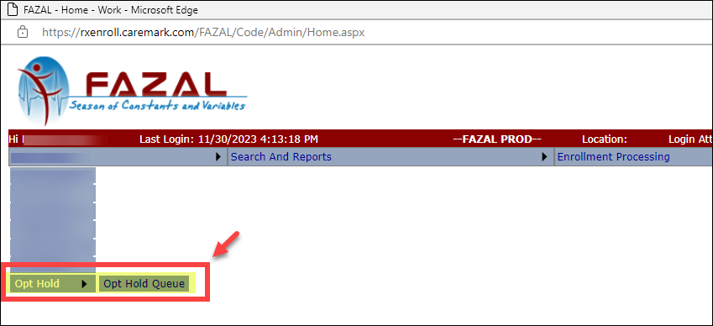  - To find the application, use Search By: Subscriber ID, Last Name, or MBI/HICN  - Enter the application Subscriber ID and click Go.  - Click on the Subscriber Id hyperlink.  - Proceed to the next step.  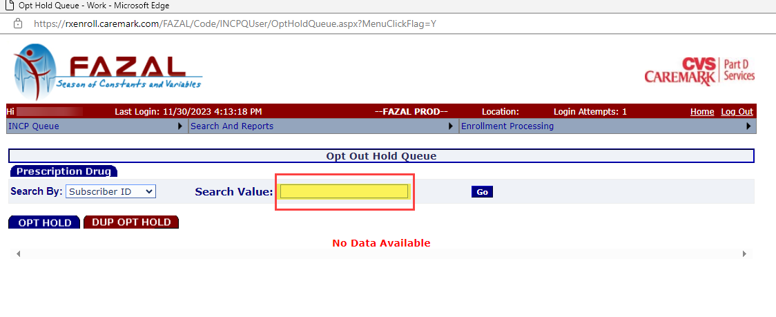  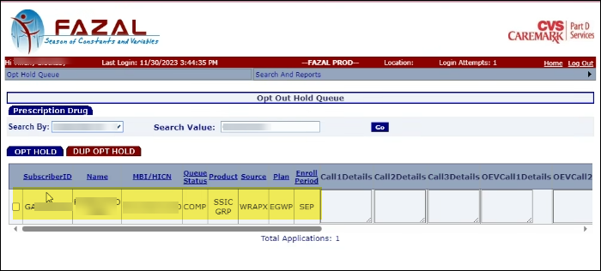  Note: If an application is not found in Opt Hold search, refer to the MED D Enrollment - FAZAL work instruction
3 | Determine whether the Opt Hold Release Date has passed by:  - Asking the beneficiary to provide the date on their Opt Hold letter.  - View a copy of the beneficiary’s Opt Hold letter in the “Last 12 Months of Communications” link in the MED D tab of PeopleSafe (O’Neil ONEClick).  - Refer to MED D - Viewing Correspondence and Requesting Reprints in PeopleSafe.
3 | If the letter states that the beneficiary… |  |  |  | Then…
3 | Needs to provide additional information to opt in/enroll |  |  |  | - Access the MED D - Incomplete Enrollments (ICE) or Enrollments with Missing Information work instruction and proceed accordingly  - Once the information has been provided, proceed to Step 6 if the beneficiary wants to opt in.
3 | Needs to opt in/opt out |  |  |  | Proceed to the next step.
4 | Navigate to Section 3 of the application and scroll down to the Comments, Opt Hold Attestation and Opt Out Method fields. Verify the Opt Hold Release Date in FAZAL.  
4 | If the Opt Hold Release Date Has… | Then…
4 | Passed | Proceed to Step 5  CCR Process Note: If the Opt Hold Release Date has passed, the Opt Hold Attestation drop down menu will be disabled.
4 | NOT Passed | Confirm the beneficiary’s decision regarding their application.
4 | NOT Passed | If the beneficiary… |  |  |  | Then from the Opt Hold Attestation drop down menu, select… | AND from the Opt Out Method drop down menu, select…
4 | NOT Passed | Does want to enroll |  |  |  | ATTESTED | Inbound call  Proceed to Step 6
4 | NOT Passed | Does NOT want to enroll |  |  |  | NOT ATTESTED/ DISCONTINUED | Inbound call  Proceed to Step 6
5 | Confirm the beneficiary’s decision regarding their application.
5 | If the beneficiary… | Then…
5 | Wants to enroll | Inform the beneficiary that no further action is necessary, and their coverage will begin on the effective date. Proceed to Step 8
5 | Does NOT want to enroll | If the beneficiary calls… |  | Then…
5 | Does NOT want to enroll | Past the Opt Out date but PRIOR to the effective date of enrollment |  | Submit the following RM Task:  Task Category: Med D Enrollment - Enrollment  Task Type: Cancellation of Enrollment  Queue: Med D Enrollment Task  Notes: The beneficiary is past the Opt-Out date for withdrawing their enrollment and are requesting to cancel their enrollment prior to the effective date. The beneficiary can be reached at <phone number>.  Proceed to next step
5 | Does NOT want to enroll | AFTER the effective date of enrollment |  | Advise the caller that they will need to submit a disenrollment request.  CCR Process Note: Access the Eligibility section of the CIF.  CCRs must follow the Opt Out/Disenrollment process provided by the client.  - This may include referring to MED D - Specialized Member Services Team (SMST) - Voluntary Disenrollment or referring all calls directly to the client.  Proceed to Step 8.
6 | Enter the applicable Customer Service Notes based on the beneficiary’s request.  Note: The CCR can add notes to the application regarding the Opt Hold process, only if it is in a Pending Queue.  If the Opt Hold Release Date has passed, the Opt Hold Attestation drop down will not be available.
6 | If the Opt Hold Attestation is… |  | Then…
6 | ATTESTED |  | In the Comments field, type or copy and paste the following statement:  “The beneficiary wants to enroll in the Plan and attests that they want the enrollment released before the 21-day hold period ends.”  Click the Save button in the bottom right corner.  Proceed to Step 8.
6 | NOT ATTESTED/DISCONTINUED |  | In the Comments and Customer Services Notes field, type or copy and paste the following statement:  “The beneficiary does not want to enroll in the Plan and will opt out of the plan before the 21-day hold period ends.  Click the Withdraw button in the bottom right corner.  Note: If correct options were not selected the following error message will appear: “Please go to Opt Hold Queue and use Withdraw option for NOT ATTESTED/DISCONTINUE”  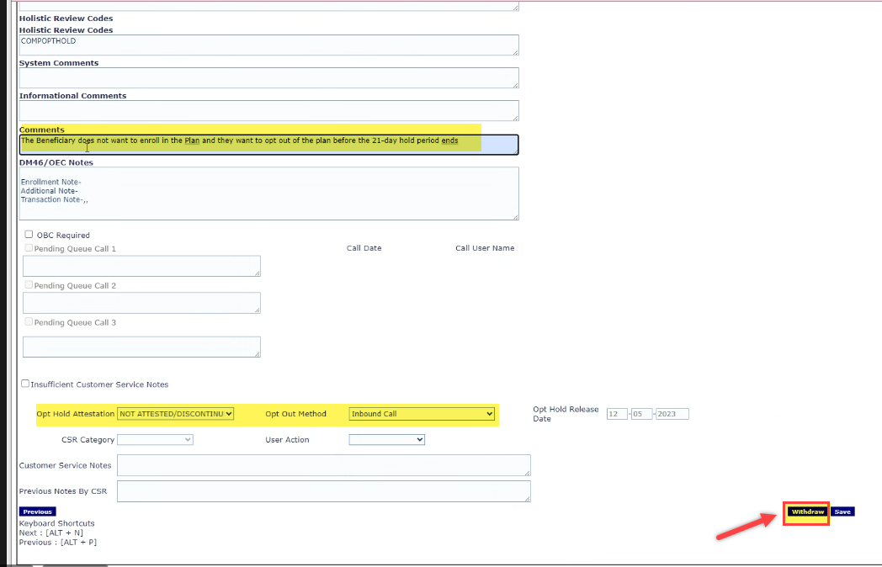  Proceed to the next step.
7 | A pop-up window will display on screen. Select Enrollee Request from the drop down and click the Ok button.  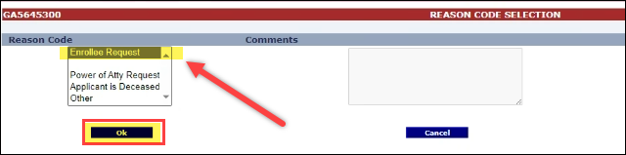  - A second pop-up window will display. Click Ok  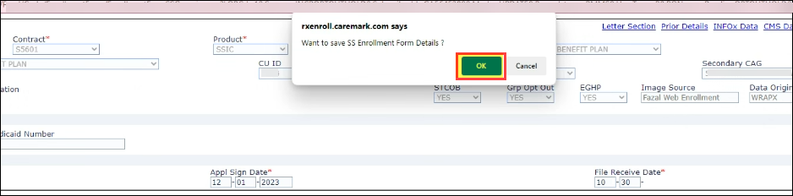  - If the application has been correctly withdrawn, the following pop-up will display. Click Ok  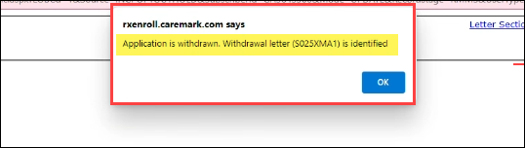  Advise the beneficiary that the opt out request has been submitted and they will receive a letter in the mail confirming this request.  Your request to Opt-Out of the enrollment has been submitted. You will receive a letter in the mail confirming your request.  Proceed to the next step.
8 | Ask if there are any other benefit questions.
8 | If… |  | Then…
8 | Yes |  | Address any benefit issues.
8 | No |  | Document and close the call using current policies and procedures.  Refer to MED D - Call Documentation.  Log Activity  1306 = Enrollment/Disenrollment

Top of the Document

Accessing Notes for an Application on Opt Hold in FAZAL

To view or add notes to the application, the SMST CCR will:
Step | Action
1 | From Step 2 of the Releasing an Application on Opt Hold in FAZAL section of this work instruction, click on the SubId hyperlink.  Result: The beneficiary’s enrollment application will display.
2 | Click on the Section 3 hyperlink at the top left of the screen.  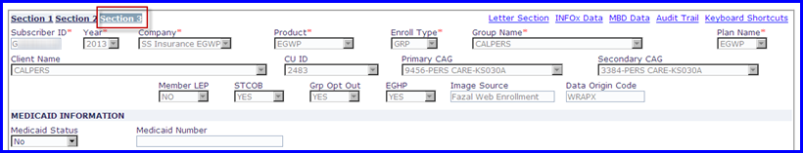
3 | Locate previous notes or comments at the bottom of the page.  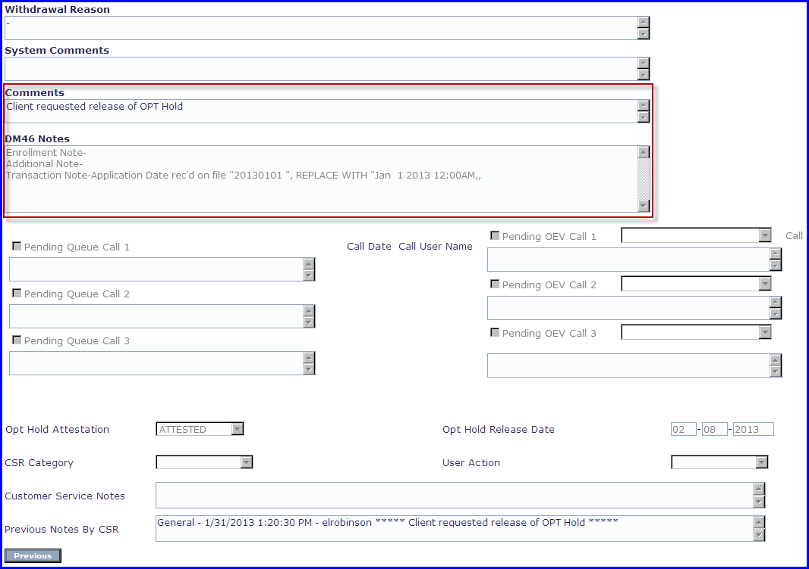  Note: The CCR can add notes to the application regarding the Opt Hold process, as long as the application is in a Pending Queue.
4 | Ask if there are any other benefit questions.
4 | If… | Then…
4 | Yes | Address any benefit issues
4 | No | Document and close the call using current policies and procedures.  Refer to MED D - Call Documentation.  Log Activity  1306 = Enrollment/Disenrollment

Top of the Document

Resolution Time
 Releasing an Opt Hold = 4 business days

Top of the Document

Related Documents
Parent SOP: CALL-0048: Medicare Part D Customer Care Call Center Requirements-CVS Caremark Part D Services, L.L.C.
Abbreviations/Definitions: Abbreviations / Definitions

Top of the Document
NOT to Be Reproduced or Disclosed to Others without Prior Written Approval
ELECTRONIC DATA = OFFICIAL VERSION - PAPER COPY = INFORMATIONAL ONLY

